Attachment 1
From:

The City University of New York

2011 Tobacco Policy Work Plan

January 2011

© 2010 CUNY. All Rights Reserved.

FOR INTERNAL USE ONLY

Table of Contents

- CUNY’s Revised Tobacco Policy . . . . . 3

- Memo from Chancellor Goldstein . . . . . 4

- Implementation Overview. . . . . . . 5

- Implementation Steps . . . . . . 5
A. Step One: Formation of a Campus Tobacco Policy . . . 5
Implementation Working Group on Each Campus . . . 6
B. Step Two: Develop and implement a Communication Plan . 9
Communication Plan: Rationale . . . . . 9
Communication Plan: Consistent Messaging . . . 9
Communication Plan: Dissemination Strategy
C. Step Three: Removal of smoking related cues . . . 9
D. Step Four: Providing training and education to staff and students 9
E. Step Five: Provide tobacco cessation support services . . 9
F. Step Six: Enforcement of revised tobacco policy . . . 10

I. CUNY’s Revised Tobacco Policy

RESOLVED, That the Board of Trustees of The City University of New York adopt the attached tobacco policy, effective no later than September 4, 2012, prohibiting (i) the use of tobacco on all grounds and facilities under CUNY jurisdiction, including indoor locations and outdoor locations such as playing fields; entrances and exits to buildings; and parking lots; (ii) tobacco industry promotions, advertising, marketing, and distribution of marketing materials on campus properties; and (iii) tobacco industry sponsorship of athletic events and athletes.
EXPLANATION: This resolution updates, expands and supersedes the policy enacted by a Board of Trustees Resolution effective January 1, 1995, which prohibited smoking inside all facilities, including vehicles operated by the University. This revised tobacco policy must be implemented University-wide no later than September 4, 2012. As the nation's largest urban public university, as a source of thousands of health-professions graduates, and as the home of the new CUNY School of Public Health, CUNY has an opportunity—and a responsibility—to set appropriate standards as an example for universities seeking to protect the health of their students and employees.
Last spring, at the request of Chancellor Matthew Goldstein, Executive Vice Chancellor and University Provost Alexandra W. Logue convened a CUNY Tobacco Policy Advisory Committee to consider if—and how—the existing policy might be expanded to better protect the health of CUNY students, faculty, and staff. After extensive research, deliberations, and solicitation of community views, the Committee recommended that CUNY’s policy be expanded as indicated in this resolution to accomplish that goal.
Across the United States, an ever-increasing number of colleges and universities are instituting tobacco-free policies: As of October 1, 2010, at least 446 colleges and universities had enacted smoke-free or tobacco-free policies for their entire campuses (indoors and out); about another 80 had enacted policies that include minor exemptions for remote outdoor areas. Other colleges and universities have not encountered significant problems enforcing tobacco-free policies.
The Central Office will support the new policy by providing training, information, and other resources across the system. Each college (and the Central Office) will be expected to submit college-specific implementation plans for review and approval by the Chancellery by no later than June 30, 2011.

II. Memo from Chancellor Goldstein

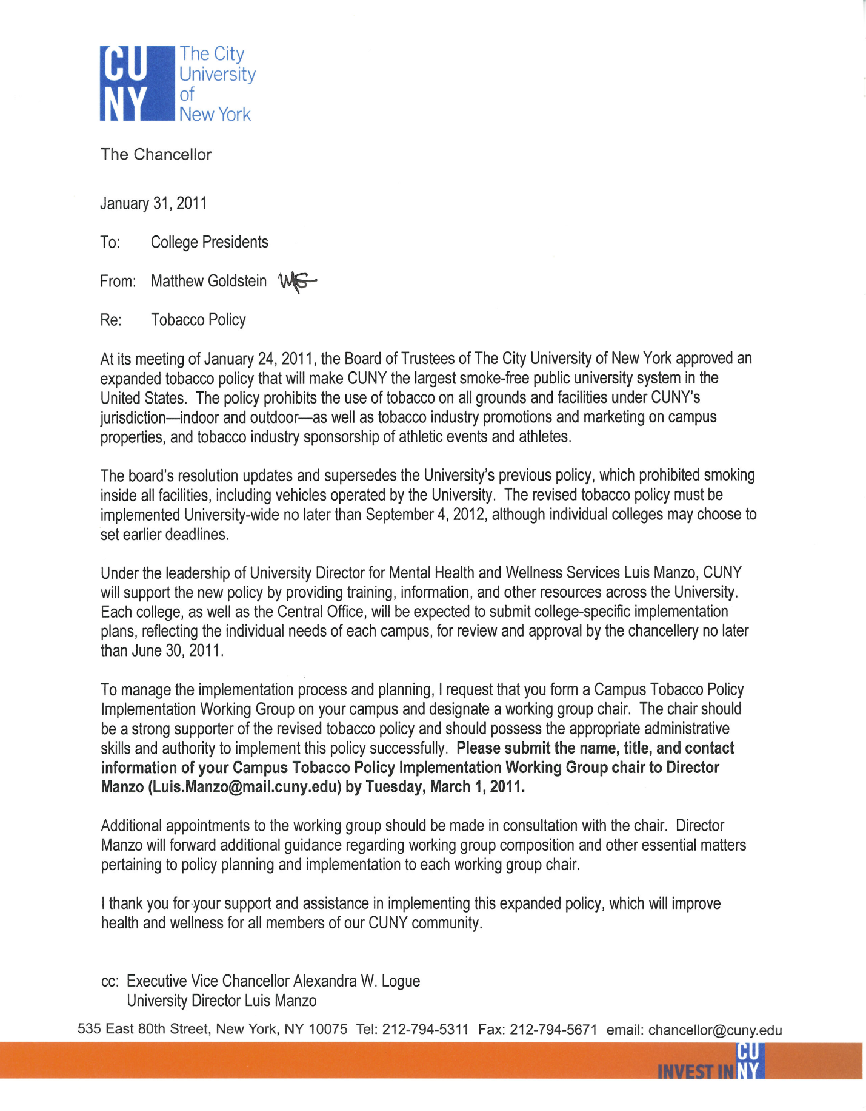

III. Implementation Overview

CUNY’s revised Tobacco Policy was approved by the Board of Trustees on January 24th2011.

Each college and university unit (Central Office 80th Street/31st street/ 57th street/41st Street, Law School, School of Journalism, Professional Studies, etc) of the University is responsible for implementing the revised policy and is expected to submit an individualized implementation plan to the Central Office by June 30, 2011. Furthermore, the University expects the full implementation of the revised tobacco plan no later than September 4th 2012.

Throughout the development and implementation of campus implementation plans, as well as during the execution phase of the policy, the members of the Central Office Tobacco Policy Implementation Working Group are available for consultation and assistance. The University Director or Mental Health and Wellness, Luis Manzo, will be coordinating the implementation of the revised tobacco policy system wide.

IV. Implementation Steps

The implementation of the CUNY’s revised Tobacco Policy should involve the following steps:
- Formation of a Campus Tobacco Policy Implementation Working Group on each campus
- Creation and execution of a campus-specific communication plan
- Removal of smoking-related cues (i.e. ashtrays, smoking lounges, etc)
- Providing training and education to appropriate staff (i.e., Public Safety, Human Resources, Dean of Students/Campus Judicial Officer) and students regarding the revised policy and its enforcement
- Providing tobacco cessation support services
- Enforcement of revised tobacco policy

A. Step One: (Campus Presidents) Formation of a Campus Tobacco Policy Implementation Working Group on Each Campus

Campus Presidents or unit administrators should appoint a Tobacco Policy Implementation Working Group Chair on each campus. This person is charged with spearheading the implementation of the revised tobacco policy and is considered the chair of the campus’s Campus Tobacco Policy Implementation Working Group. This individual should be a strong supporter of the revised tobacco policy as well as possess the appropriate administrative skills and authority to successfully implement this policy.

In consultation with the campus president, the Working Group Chair will appoint additional members to the working group.

The Working Group should be comprised of a diverse group of motivated individuals representing the following offices and populations: Student-elected representatives, Health and Counseling Center professionals, Faculty, Student Affairs administrators, Chief Academic Officer, Buildings and Grounds, Administrative and Office staff, Residence Life staff (if applicable), Judicial Affairs, Public Safety, Human Resources, Facilities Management, Custodial, Legal Counsel, Media Relations, and if possible a member of the campus’s local neighborhood association.

As indicated in its name, the Campus Tobacco Policy Implementation Working Group is responsible for coordinating the implementation of CUNY’s revised Tobacco Policy.

B. Step Two: (Campus Tobacco Policy Implementation Working Group)
Develop and implement a Communication Plan

The goal of CUNY’s revised tobacco policy is to provide a safe and healthy working and learning environment for all CUNY faculty, staff, students, and visitors. All too often the notion of a “smoke-free” or “tobacco-free” campus is misinterpreted as being “anti-smoker.” This is not the intention of CUNY’s revised tobacco policy. The revised policy is not designed to punish or single out tobacco users, rather its purpose is to support members of the CUNY community in being as healthy as possible. Although the revised policy is intended to support faculty, staff, and students who use tobacco and who want to quit, it is not intended to force anyone to quit smoking.

A communication plan should clearly outline a:

- Clear rationale regarding why CUNY updated its tobacco policy

- Clear and consistent messaging regarding the policy

- Dissemination strategy that details how and when information regarding the policy will be communicated to the campus community. Campus dissemination plans should include a detailed plan for communicating the revised policy to the faculty, staff, and students.

Communication Plan: Rationale
CUNY has revised its tobacco policy to further cultivate a healthy working and learning environment for CUNY employees, students and visitors. The policy focuses on the use of tobacco not on the people who use tobacco. CUNY respects an individual’s right to use tobacco; however CUNY requests that tobacco users refrain from smoking and using tobacco products on campus property.

Communication Plan: Consistent Messaging
Your communication plan should include a few simple messages or “talking points” that explain why CUNY has revised its tobacco policy to encompass all CUNY property. Key messages to the CUNY community may include:
- “We have revised this policy to provide a healthy and safe environment for employees, students and visitors, and to promote positive health behaviors.”
- “We are not saying you must quit smoking. But we are saying you cannot use tobacco while you are on CUNY property. If you are ready to quit, we want to support your efforts.”
- Starting September 12, 2012, we will no longer permit use of tobacco products on our campus. However, campuses have the option of and are encouraged to set an earlier date for implementation.
- (Name of Tobacco Policy Implementation Working Group Chair or designee) will be responsible for this initiative. Please contact her/him if you have suggestions on how to improve our process or if you have questions or concerns.

Communication Plan: Dissemination Strategy
It is recommended that campuses employ a broad dissemination plan to educate their community about CUNY’s revision to the Tobacco policy. The following are characteristics of an effective communication plan. Approval of plans by the Chancellery will depend on the incorporation of the below items:

Timing and Frequency:
- Plan on providing members of your community with as much advance notice regarding the change to the tobacco policy as possible. Campus constituents should be notified of the change in the policy as soon as possible and no later than six months prior to the date at which the policy will go into effect.
  - Prior to the implementation of the revised policy, communicate with faculty, staff, and students monthly via email, newsletters, and signs about the policy change.
    - Memos, e-mails, notices in employee publications, all employee voicemails, staff meetings, union representatives, presentation to managers/department chairs and/or regular memos or e-mails from your campus administrators are great ways of informing your campus about the revised policy.
- Communications should outline how your campus will be implementing and enforcing the policy.
- Send out final announcement from either the Campus President or chair of the implementation working group immediately before the policy takes effect.

Use Various Channels/Approaches to Communicate Your Message
- Inform all members of the campus community about the revision to the tobacco policy
  - Distribute the campus tobacco policy on a semi-annual basis.
  - Include and clearly post the revised policy in employee and student handbooks, the college’s website, and in other relevant publications.
  - The policy should be shared with parents, alumni, and visitors
- Include the policy in prospective student materials (i.e., admissions brochures) in both printed and electronic formats.
- Distribute brochures and hang post posters announcing when the policy will go into effect.
  - (optional) Initiate a “countdown to implementation” campaign. Place a sandwich board with a flip chart in a prominent place (near the front entrance of the hospital inside and/or outside, in front of the cafeteria, etc.). Use it as a countdown (number of days until the campus goes 100% tobacco-free campus-wide) and begin 90-100 days prior to policy implementation.
  - (optional) Distribute cards, posters, and table cards in cafeterias describing the policy and how it will be implemented.
- Advertise cessation resources to assist tobacco users who want to quit.
- Provide tobacco-free policy education sessions.
- Provide workshops on tobacco use and cessation support services at CUNY.

Signage and Communication Venues:
- Post temporary signage announcing the revision of the tobacco policy and CUNY’s plans to go 100% Tobacco Free. After September 4th 2012, (or the effective date for that campus) install permanent signage throughout campus.
- Place banners on the exterior of campus buildings and signs within all buildings announcing CUNY’s revised tobacco policy to become 100% tobacco-free campus-wide. Include the implementation date on all signage.
  - Focus on existing smoking areas. Make sure to heavily cover any existing outdoor smoking areas (benches, parking lots, etc.) with signage.
- Determine the number of entrances to campus/buildings and install freestanding signage.
  - Pay close attention to buildings and spaces on the perimeter of campus property.
  - If signs are only located on campus buildings, people will have a difficult time understanding that the policy applies to outdoor areas as well as indoor areas.
  - Pay attention to campus boundaries. Make sure that there are major signs at every interface between campus and non campus property.
- Display signs in all parking areas. Tobacco use is not allowed in cars that are on campus.
- Place signs in major traffic areas. Attach signs to easels announcing that the campus is going 100% tobacco-free campus-wide. After the signs have been in one location for a month, move them to a new location to recapture people’s attention.
- Modify or add to pre-existing “No Smoking” signs to let people know that the entire campus, both inside and out, will be going tobacco-free.
- Incorporate messages about the policy, tips for successfully quitting, and information about resources, into electronic message boards throughout campus.
- When campus property abuts public property, where smoking is legal/permitted but the smoke may drift onto campus property, post signs on the abutting campus property requesting (vs. ordering) that people walk away from campus boundaries to use tobacco products.

C. Step Three: (Campus Tobacco Policy Implementation Working Group)
Removal of smoking related cues (i.e. ashtrays, smoking lounges, etc)

Coordinate with your campuses Buildings and Grounds department to remove all containers used for tobacco trash, ashtrays, and any smoking lounges or sites on campus, if they exist. This step should be completed prior to the date (September 4, 2011 or sooner, depending on the campus) that the revised tobacco policy goes into effect and when permanent signage is posted.

D. Step Four: (Campus Tobacco Policy Implementation Working Group)
Providing training and education to staff and students

Campuses should indentify appropriate faculty, staff, and students to participate in cessation counseling trainings coordinated by the Central Office in collaboration with the CUNY School of Public Health and the New York City Department of Health Bureau of Tobacco Control. Individuals that should participate in training and the associated content area are as follows:
Individuals | Topics
Human Resources staff, Dean of Students, Campus Judicial Officer, members of implementation working group, Campus administrators, and Public Safety, as well as student and faculty governance leaders. | - Implementing of the revised policy  - Confronting someone who is using tobacco on campus  - Enforcing the revised tobacco policy
Mental Health Clinicians/Health Services Nurses | - Screening for tobacco use  - Tobacco cessation protocols and treatment
Peer Educators/Faculty | - Assisting/supporting a friend’s desire to stop using tobacco

Campuses should also explore additional training opportunities for these individuals to ensure a smooth and effective implementation of the revised tobacco policy.

E. Step Five: (Campus Tobacco Policy Implementation Working Group)
Provide tobacco cessation support services

When promoting cessation services, you should approach the issue with an empathetic stance. Such an approach should recognize the power of nicotine addiction and should focus on offering support and should reaffirm the college’s commitment to the health of its faculty, staff, and students.

Tobacco cessation support services should encompass many different of types of assistance in order to meet the diverse needs of faculty, staff, and students who use tobacco products.

The promotion of tobacco cessation support services should be designed to:
- Assist those who are interested in stopping the use of tobacco in doing so.
- Further advertise CUNY’s revised tobacco policy.

This step should involve the following actions:
i. An evaluation of tobacco cessation support services available on campus
- The types of services faculty, staff, and students would like to see and would use on campus.
- Campus efforts to advertise city, state, and local cessation support hotlines, services, etc. via both print and electronic media.

ii. Educational programming about tobacco cessation and cessation support services

iii. Educational programming that supports a tobacco-free lifestyle (e.g., stress management, weight management and exercise activities).

iv. On site tobacco cessation services
- Establish classes, seminars, or groups for those who are interested in reducing or eliminating their tobacco use.

v. Referral to tobacco cessation services
- Maintain an up to date listing of cessation resources in the local community available to faculty, staff, and students (including a list of programs and available medications for the treatment of tobacco dependence).
- Provide linkages to CUNY’s Employee Assistance Programs (EAP), health programs offered by health insurance plans, community-based organizations, as well as NYC DOHMH Bureau of Tobacco Control smoking cessation services.
- Participate in the Great American Smoke Out (http://www.cancer.org/Healthy/StayAwayfromTobacco/GreatAmericanSmokeout/index)
- Promotion of New York State’s Quitline: 1-866-NY-QUITS (1-866-697-8487) http://www.nysmokefree.com/

F. Step Six: Enforcement of revised tobacco policy

Each campus is expected to comply and enforce CUNY’s revised tobacco policy no later than September 4th, 2012. How each campus chooses to enforce the revised policy is up to the discretion of each campus president and his/her Campus Tobacco Policy Implementation Working Group.

CUNY’s vision for the enforcement of the revised tobacco policy, is one in which a tobacco-free campus is viewed as the shared responsibility of all those in the campus community, tobacco users and non-users alike. While enforcing the policy campus officials and representative are encouraged to be friendly and respectful. Discussions about the revised tobacco policy should be brief, educational, and non-confrontational.

CUNY’s hope is that faculty, staff, and students can work together to enforce this policy through friendly interactions. Concerns about the policy can be addressed by emphasizing the goal of ensuring a safe and accessible campus for all, and by encouraging open discussion and airing of any questions.

Compliance with the policy will depend largely on how effectively the campus community is educated about the revised policy. Thus, the implementation of a clear communication plan is vital. The desired effect of a campus’s communication plan is a shift in social norms regarding tobacco use on campus, thus encouraging high compliance with the revised policy.

To bolster compliance rates the following passive and active enforcement methods could be used:
Passive Enforcement Methods
- Highly visible, permanent signage across campus
- Additional temporary signage used during large events

Active Enforcement Methods
- Distribution of reminder cards to violators
- Focus on positive intervention and peer enforcement, developing protocols for campus community members to respectfully ask others to comply and/or report noncompliance.

One approach to addressing an individual who is observed smoking or using tobacco on CUNY property after September 12th 2012 (or an earlier effective date) is to: 1) ask him /her to stop, 2) remind him/her of the revised policy, and 3) inform him or her about tobacco cessation support resources available on campus.

